**A**

**Berth Scheduling System**

**Requirement Document**

**R.Ramesh**



Rev0, 08-April-2019

# Introduction

# Work Flow chart

This is a simple flow chart, edited by one user. Other normal users can only view (no edits allowed0. Refer the Menus/TABs below.

# Menus/TABs

# Below are the Menus/Tabs in Material Pass software (user interface pages)

**Admin**

Create User

User list

**Dropdowns**

**Dashboard**

**History**

**Berth Status list**

Create Berth

**New Schedule**

Add Cargo

Add Berth

Berth schedule list

Completed list

# Dropdowns TAB –(future work )

# Create Berthing

# The requester creates a material pass here with following detail filled and saves the form.

|  |  |
| --- | --- |
| **ETB Time** | Calendar date/time format |
| **ETU Time** | (date format) |
| **Berth** | A/B/C (Drop down) |
| **Vessel Name** | Free text |
| **Operator** | Free text |
| **Cargo Type** | Dry/Liquid/container ( dropdown) |
| **Service** | Free text |
| **Import** | Numeric entry |
| **Export** | Numeric entry |
| **CI** | Numeric entry |
| **Crane rate** | Numeric entry |
| **Length (m)** | Numeric entry (decimal) |

Save

Create

Notes: Berth date: shall show conflict of dates/time

# Berth schedule list

# The list with filters will help to reschedule /edit the information.

|  |  |  |  |  |  |  |  |  |  |
| --- | --- | --- | --- | --- | --- | --- | --- | --- | --- |
| **S.No** | **Berth** | **Vessel name** | **cargo** | **ETB date/time** | **ETU**  **date/time** | **No of hours of docking** | **?** |  |  |
| 1 | A |  |  |  |  |  |  | **Edit** | **Close** |
| 2 | B |  |  |  |  |  |  | **Edit** | **Close** |
| 3 | C |  |  |  |  |  |  |  |  |
| 4 | A |  |  |  |  |  |  |  |  |
| 5 | A |  |  |  |  |  |  |  |  |
| 6 | C |  |  |  |  |  |  |  |  |

* Provide suitable filters (Berth, From date to date)
* Only authorized person will be able to edit and close. Once closed, the list will go to the history.

# History Table

Here the list of material sent & returned will be available for future reference

|  |  |  |  |  |  |  |  |  |  |  |
| --- | --- | --- | --- | --- | --- | --- | --- | --- | --- | --- |
| **S.No** | **Berth** | **Vessel name** | **cargo** | **ETB date/time** | **ETU**  **date/time** | **No of hours of docking** | **-** | **-** | **-** | **-** |
| 1 | A |  |  |  |  |  |  |  |  |  |
| 2 | B |  |  |  |  |  |  |  |  |  |

* Provide suitable filters (Berth, From date to date)
* In the table, show all the relevant information. The above two table may not be needed if we have excellent calendar library which can help to do the edit from there.

# User Role

* Normal user ( specific port/View option)
* Normal corporate user (access to multiple ports/sites)..This is required for future..
* Admin
* Scheduler (port /site specific only)

# Dropdowns - TAB

* Provide options to edit dropdowns ( not needed now…future)

# Dashboard

Calendar type feature to visualize the berthing of vessels.

* 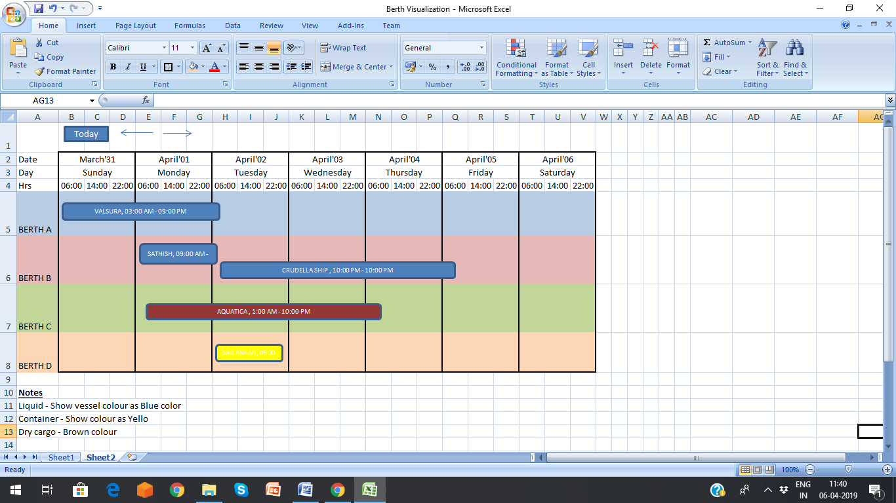Visualization should have capability to vertically go down, in the future when multiple berths are added.
* When we do multiple ports, we should be able to go the multiple calendar view (can be provided with different tabs) for corporate users.

# Admin

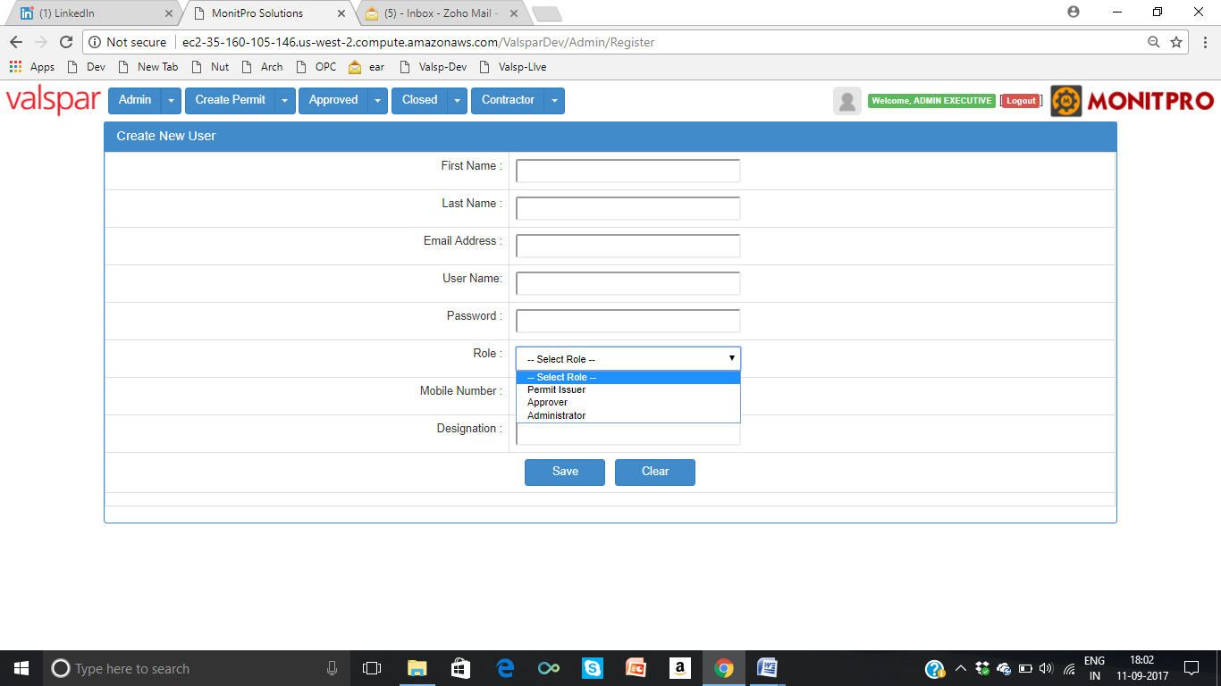

* The above will have option to have port/site specific role / Corporate user role

# User List Table

* List of users and the roles will be displayed in the table.

# Future additions

* Shall show the percentage of Berth utilization, productivity calculation, time spent/MT at berth etc in graphs
* It could also have any new features the management wants
* Presently, we will focus on one specific site. Later, we should be able to add many sites.